**3-phase full bridge rectifier unit:**

In order to control the voltage at the input of the buck converter we should first convert ac signal into some form that we can extract some d.c signal from it. Therefore, we have decided to used 3-phase full bridge rectifier. Because it can provide higher voltage compared to half and single phase ones, there will be a wider range at the input of the buck converter to control that voltage. for the commercial product we choose “SBR 3516” it can conduct 38A and bear Vrrm=1600V its ratings are really good for our puırposes. That product is a complete bridge rectifier in other words, we did not deal with single diodes to form an full bridge rectifier so, it provides an easy implementation and compactness in the circuit also, we use some golden foot (see fig...=) to embed that module to the stripboard because in that way we can simply pull and push the module easily to that place. Finally, its advantageous in terms of the filter component size because its output voltage frequency is six times of its input frequency and that provides higher fundamental harmonic to eliminate which easier than lower one.

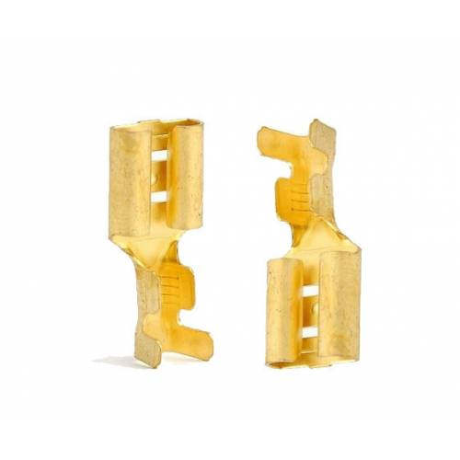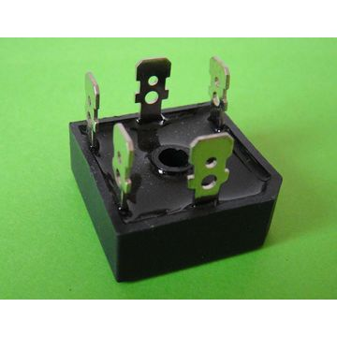

figure ?? : the figure of the golden foot and SBR-3516 module.

**Some theoretical calculations for rectifier**

(*) VOUT=1.35RMS

(**) fOUT=fin*6

**Test result for bridge rectifier**

In order to test the rectifier module we simply connect it without any load and observing its ripple by a oscilloscope probe. As can be seen from the figure below, we have 220 mV ripple however we take this measurement in AC coupling mode. Therefore, mean voltage does not seem at same screen however it corresponds to 193V mean voltage according to measurements obtained from multimeter.

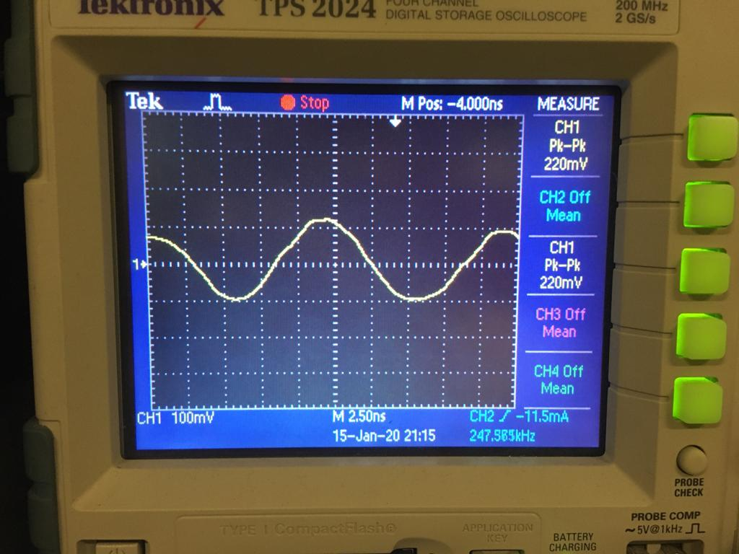

Figure ??: the ripple of the output of the full bridge rectifier.

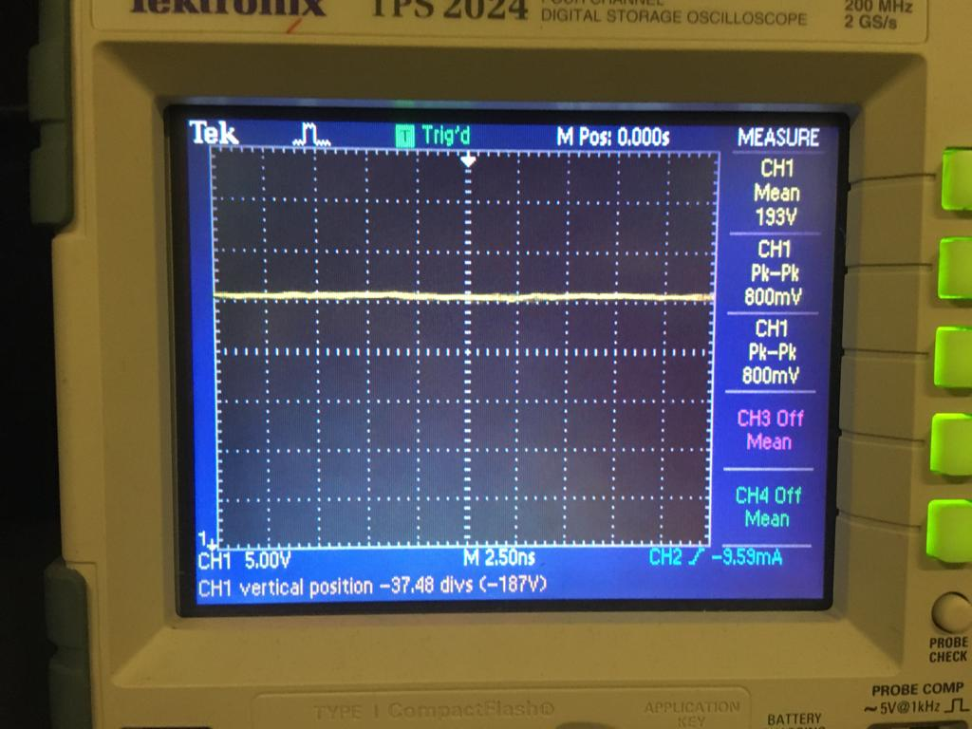

Figure??: the output of the full bridge rectifier measured at DC coupling

(note: peak to peak value can not measured at that Voltage scale because it is hard to see for the oscilloscope to obtain data at that big scale)